SQL Joins Lab Assignment
Tables:
Department (dept_id, dept_name, building)
CREATE TABLE Department (
dept_id INT PRIMARY KEY,
dept_name VARCHAR(50),
building VARCHAR(30)
);
Student(student_id, name, dept_id, city)
CREATE TABLE Student (
student_id INT PRIMARY KEY,
name VARCHAR(50),
dept_id INT,
city VARCHAR(30),
FOREIGN KEY (dept_id) REFERENCES Department(dept_id)
);
Course(course_id, course_name, dept_id, credits)
CREATE TABLE Course (
course_id INT PRIMARY KEY,
course_name VARCHAR(50),
dept_id INT,
credits INT,
FOREIGN KEY (dept_id) REFERENCES Department(dept_id)
);
Enrollment(enroll_id, student_id, course_id, semester, marks)
CREATE TABLE Enrollment (
enroll_id INT PRIMARY KEY,
student_id INT,
course_id INT,
semester VARCHAR(10),
marks INT,
FOREIGN KEY (student_id) REFERENCES Student(student_id),
FOREIGN KEY (course_id) REFERENCES Course(course_id)
);
Demo Data:
INSERT INTO Department VALUES
(1,'CSE','Block A'),
(2,'ECE','Block B'),
(3,'ME','Block C'),
(4,'Civil','Block D');

INSERT INTO Student VALUES
(101,'Amit',1,'Delhi'),
(102,'Riya',1,'Noida'),
(103,'Sohan',2,'Delhi'),
(104,'Neha',3,'Kanpur'),
(105,'Rahul',NULL,'Lucknow'),
(106,'Priya',2,'Noida');

INSERT INTO Course VALUES
(201,'DBMS',1,4),
(202,'AI',1,3),
(203,'Digital Circuits',2,4),
(204,'Thermodynamics',3,3),
(205,'Surveying',4,3);

INSERT INTO Enrollment VALUES
(1,101,201,'Sem1',85),
(2,101,202,'Sem1',78),
(3,102,201,'Sem1',90),
(4,103,203,'Sem1',72),
(5,104,204,'Sem1',65),
(6,106,203,'Sem1',88);
Use the provided schema and data to solve join queries.
1. Show student name with department name.
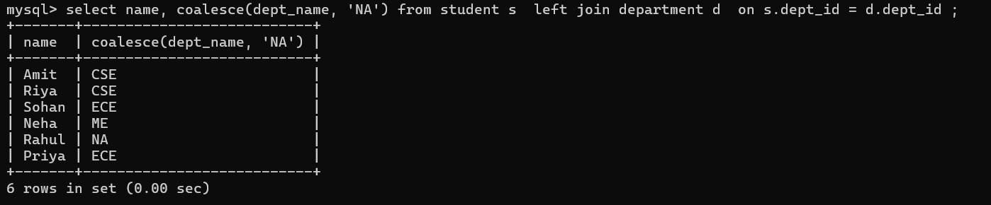
2. List all students with courses.
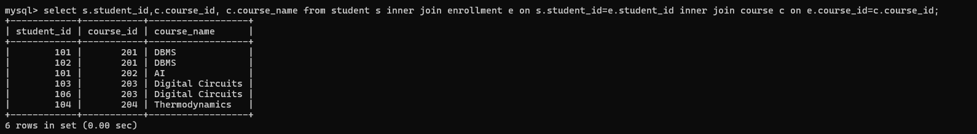
3. Display student, course and marks.
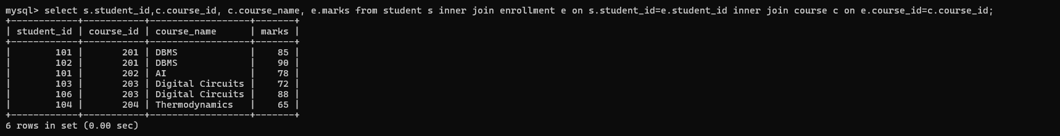
4. Show courses by department.
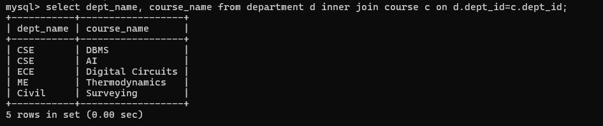
5. Show all students even without department.
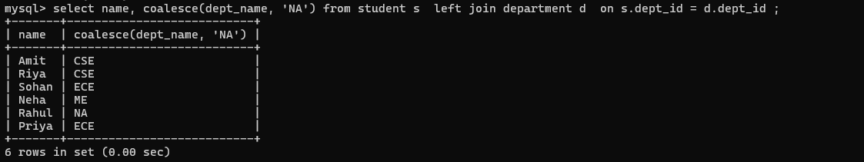
6. Show all students even without enrollment.
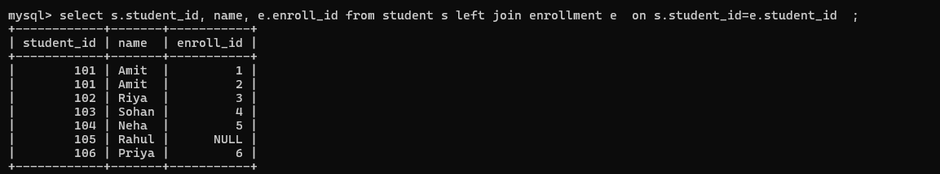
7. Show all departments even if no students.
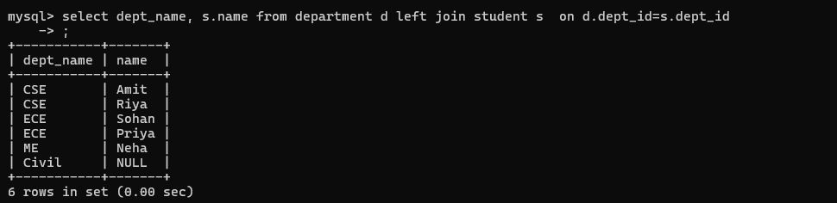
8. Show all courses even if no enrollment.
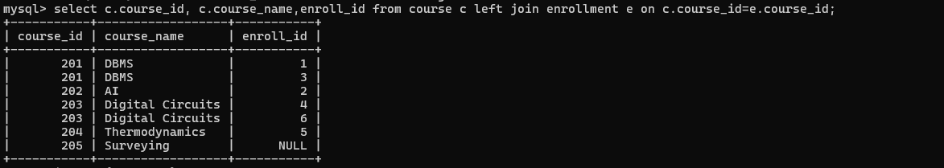
9. Full join students and departments.
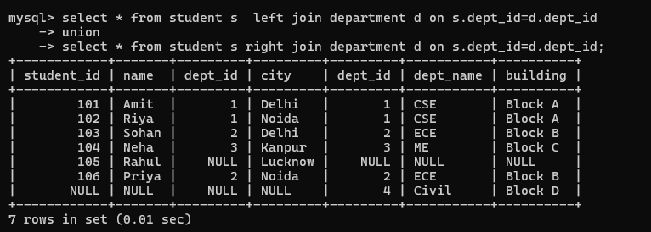
10. Show student, department, course, marks.
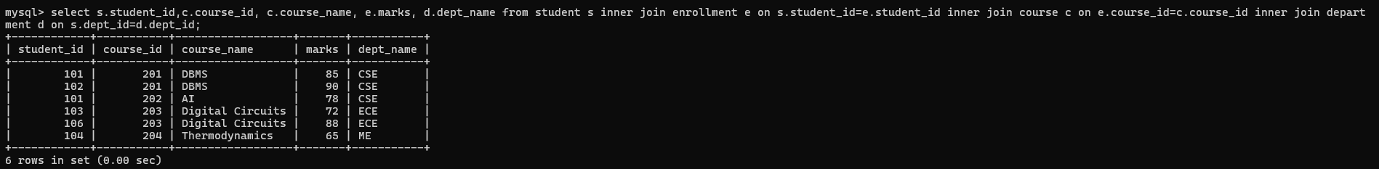
11. CSE students scoring above 80.
12. Count students per department.
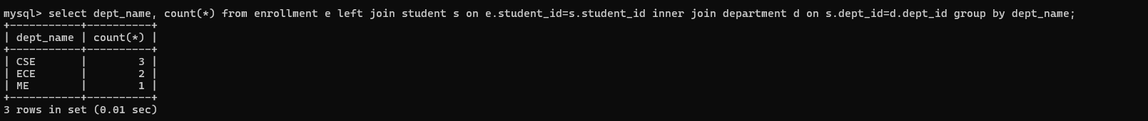
13. Average marks per course.
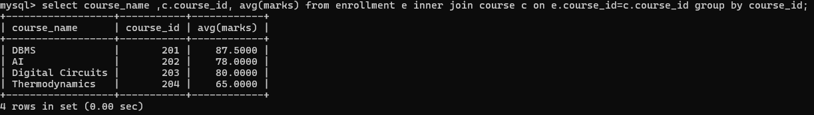
14. Count students per course.
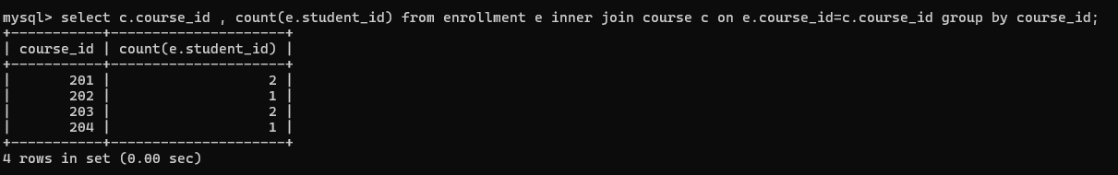
15. Courses with more than 1 student.
16. Departments with more than 2 students.
17. Students from same city.
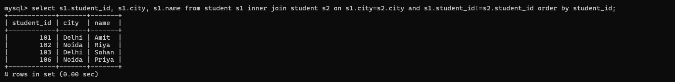
18. All student-course pairs.
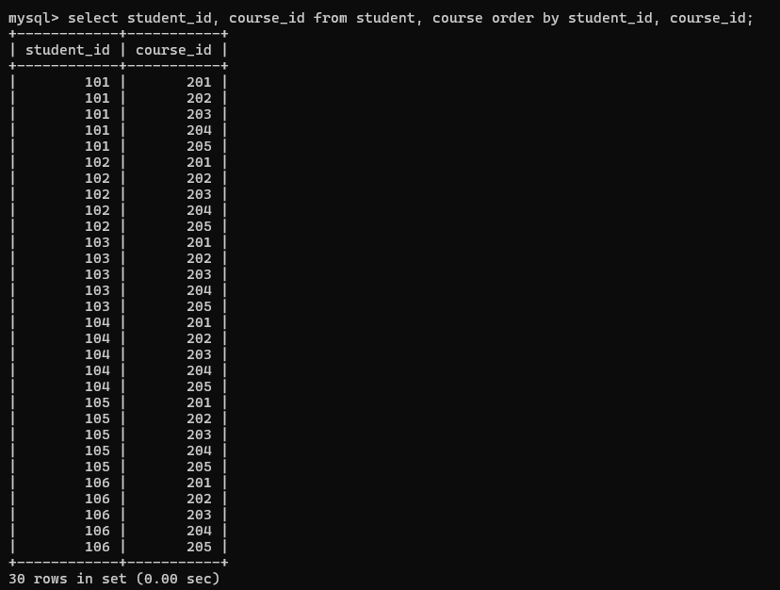
19. Top scorer in each course.
20. Department with highest average marks.

